Father’s Day Gift Order Form
Each year at the Somersby P&C Father’s Day Stall we see that students
love the excitement of choosing a gift for the special men in their life.
This year we are pleased to offer a range of fun & practical Father’s Day Gifts.
Orders forms & cash payment can be placed into the school’s mailbox, or email your order to somersbypandc@gmail.com (see below for online payment details).
Please don't delay, stocks are limited and may sell out.
Your Name:_____________________________________________
Contact number or email:__________________________________________________

Item | Description | Quantity | Price | 2nd preference if your 1st is sold out | Total $
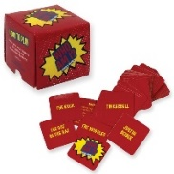 | “Who Am I” Game  A classic family game  Size 56mm x 56mm x 53mm |  | $5
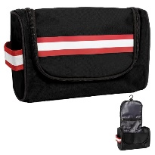 | Racer Wet Pack  Store all your essential grooming and bath items.  Size 270mm x 135mm x 160mm |  | $5
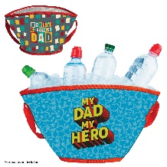 | Party Cooler Bucket  Cooler bucket with carry handle  Size 300mm x 385mm |  | $5
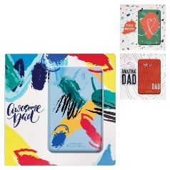 | Photo Frame  Fresh bright photo display  Frame size 180mm x 13mm x 180mm  Photo size 90mm x 140mm  3 designs |  | $5
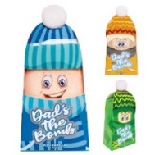 | Dad’s The Bomb Fizzer  Iced Vanilla fragrance bath bomb for a relaxing soak  3 designs |  | $5
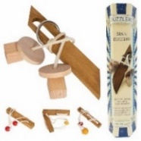 | Large Wooden Puzzle  Separate the pieces and try to reassemble.  4 designs |  | $5
 | TOTAL AMOUNT
Order Forms & Payment Due by
Wednesday 1st September:
Somersby P&C account
BSB: 062 628 Acc#: 0090 4426
Reference Number: Your Name

Collection Date & Time:
Orders can be collected from the school contactless drive-through
Friday 3rd September
from 2:40 – 3:15

