MAY 2021
Dear Students, Parents and the Families of the Our Lady’s School Community,
We are taking part in ‘Dance for Sick Kids’ and we want you to join us!
Our Lady’s PS has registered to participate as a school in the ‘Dance For Sick Kids’ Fund-Raising Event which starts next week during Family Week – 15th May – 21st May, to raise funds for the Ronald McDonald House Charities. Over 60,000 families with a seriously ill or injured child rely on these House Charities in Australia each year – and we would love to help!
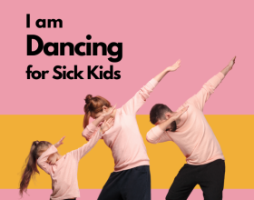

What’s the challenge? That’s the best part – you choose! Take on the challenge to dance 30mins, 60mins or 120 minutes each day! Your dance minutes in studio count towards your goal!
Check out the video link below for more information:
https://www.danceforsickkids.com/
**Below is the link for Students, families, parents & Staff to access and to join our School Team!**
If parents, child /children or families would like to participate and have some fun whilst raising money for a great cause, type in or click on link below!
https://www.danceforsickkids.com/fundraisers/ourladysdancers
Let your friends, work colleagues and family members know about your dancing adventure and get them to sponsor you! You can dance for however long you have time for each day and keep dancing well into June to raise as much money as you can!
*Any funds raised will collectively go into our school team - Our Lady's Dancers.*
Some of the choreographers include Marko Panzic, Thomas Lacey, Karli Dinardo and more!
You can see the full list here: danceforsickkids.com/workshops
Participate as a family or on your own
and make it FUN!

Thanks for your support!
Ms Connie Antenucci
(Performing Arts Teacher)

