
PENDLE HILL PUBLIC SCHOOL
Pendle Way, Wentworthville 2145
Phone: 9631 8253 Fax: 9896 3082

SeeSaw at Pendle Hill!


Dear Parent/Carers,

Seesaw is a digital portfolio that gives you real-time glimpses into your child's school day. Seesaw helps you stay in the loop and gives you an opportunity to support your child's learning at home.

So how does Seesaw work?

Each child gets their own journal in the Seesaw app and your child’s teacher will periodically add entries to it, such as photos, videos, drawings or notes. When the journals have been updated with something new, you will receive a notification and can like or comment on the entry.

Are my child’s work and photos safe?
In order for Seesaw to be used your child’s name will be entered so their work and photos/video can be tagged to their journal. Student journals are not shared publically on the internet and can only be accessed by your child’s teacher, yourself or anyone you share the login QR code with. Often the photos/video will involve more than one student and so this photo will become a part of multiple children’s journals. This means that the photo/video can be viewed by anyone viewing those other children’s journals. We ask that parents limit any sharing of their login QR code to close family.

So how do I get started?
- Search for “Seesaw Parent and Family” in the iTunes App Store or Google Play Store Store and download the app. |     
2. Tap “Create Family Account”* and scan the QR Code (you will receive the QR Code when you return this permission form). | 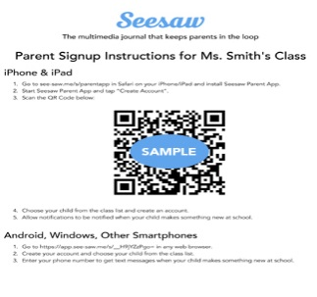
3. Create your account.
Allow notifications to get real-time updates and check out what’s in your child’s journal.

Please contact your child’s teacher with any questions about Seesaw or if you are experiencing difficulty creating an account. With your help, we can continue building our school community of lifelong learners and more closely connect learning at school with home and families.

Please compete the following permission slip and return to your child’s classroom teacher as soon as possible.

Kind Regards,

Gabrielle Buczynski
Principal

---------------------------------------------------------------------------------------------------------------------------------------

Student Name: ________________________ Class: ____________

I give permission to enter my child’s name on the Seesaw app to establish a student journal for them.

I give permission to upload photos, work or video of my child into their Seesaw app student journals. I understand I will be able to view these photos.

I understand photos of groups of students may be included in the journals of all children in the photograph and seen by anyone viewing those journals.

I understand Seesaw is an external application, which holds uploaded materials outside the Department of Education servers. I understand that the Seesaw application has privacy policy, which can be viewed on their website.

Parents Name: __________________________

Signature: ______________________ Date: _______________

